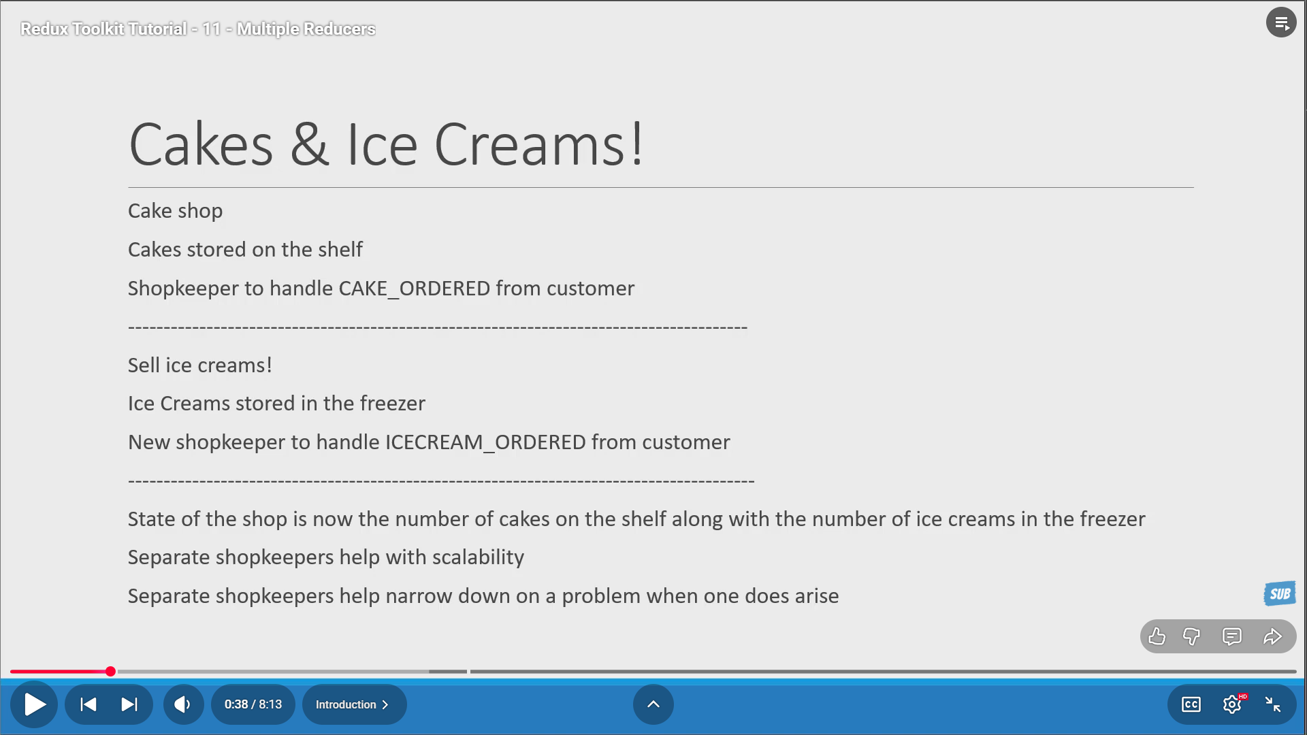
The shopkeeper is nothing but the reducer. Now with ice cream also present, we will have another shopkeeper which will be represented by another reducer.
So we have 2 reducers in total now – one each for cake and icecream.
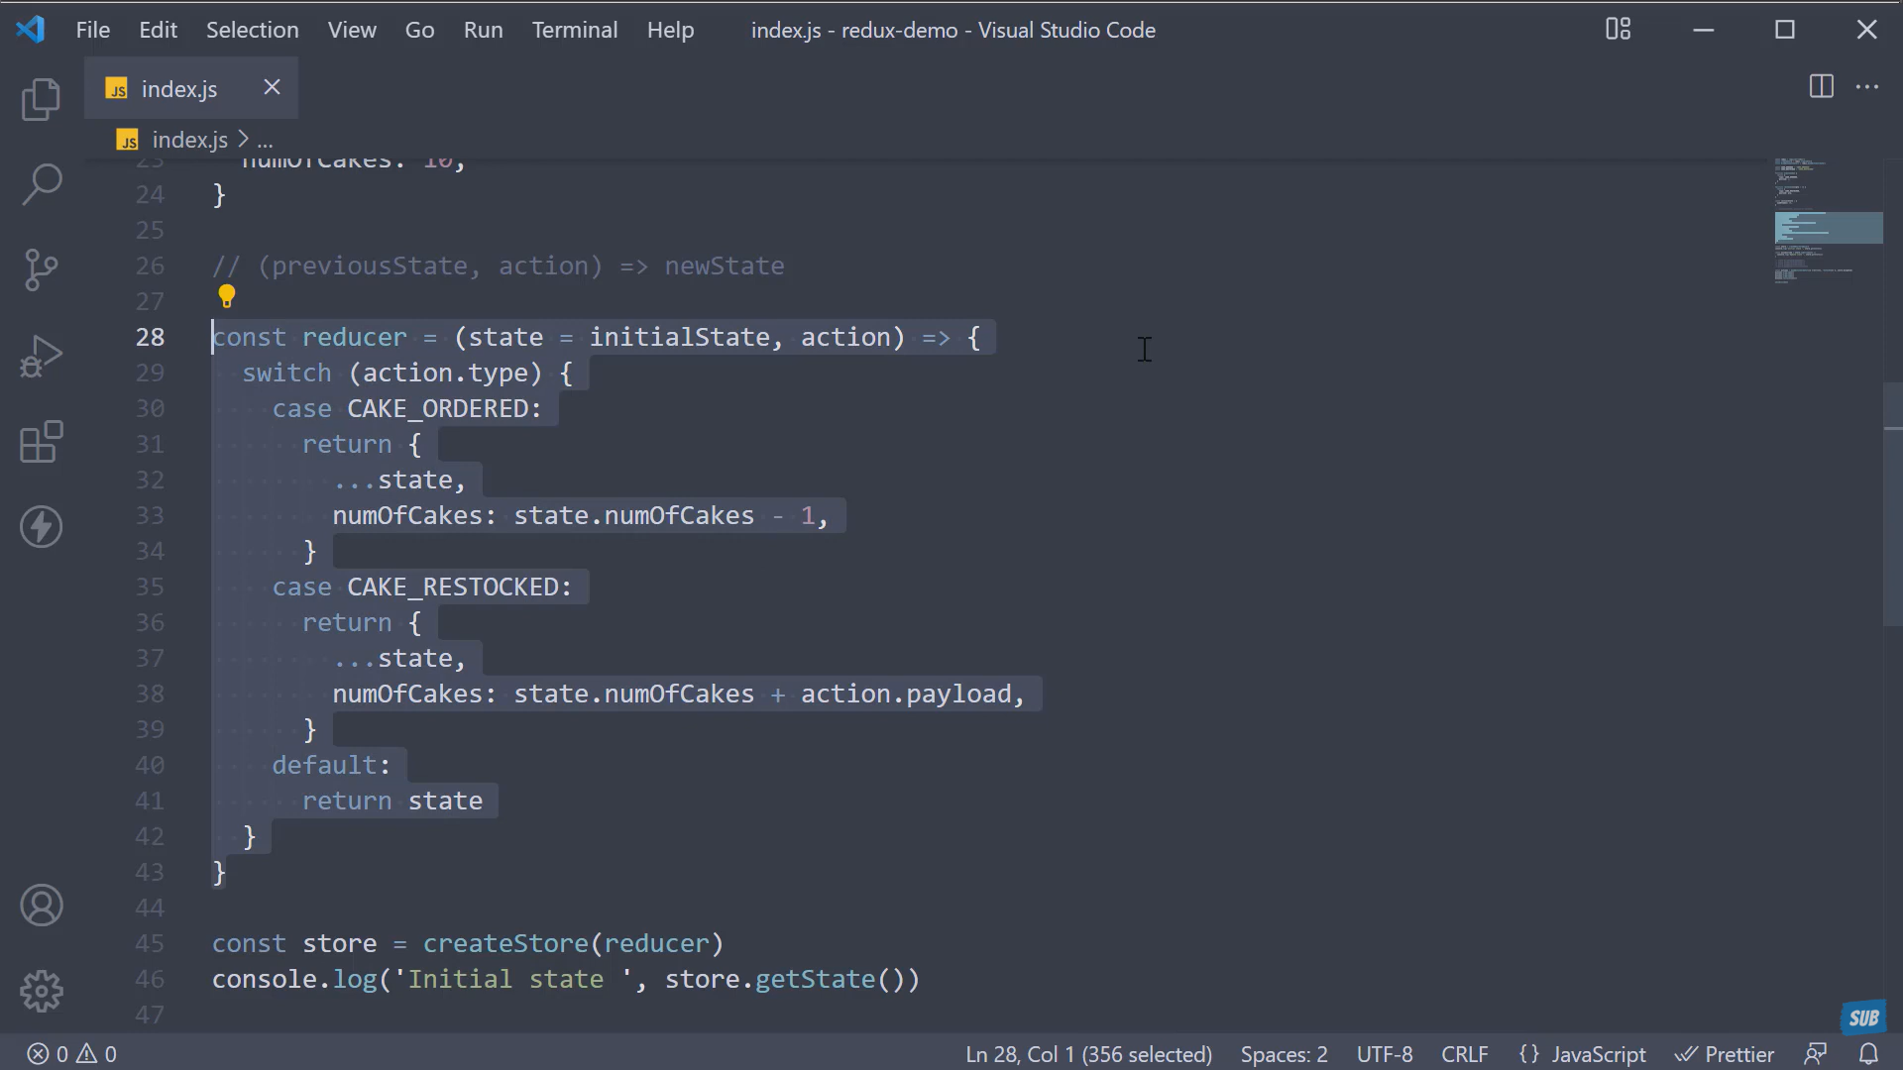
Cake Reducer – 28

